TEST RESULT WITH PARNERINTERGRATIONBFF

- Start docker:
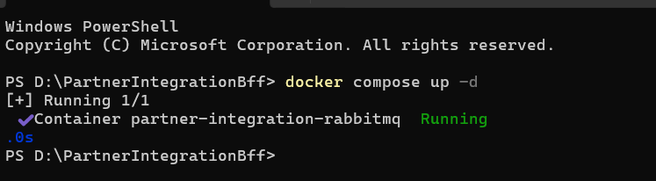

- Start API services
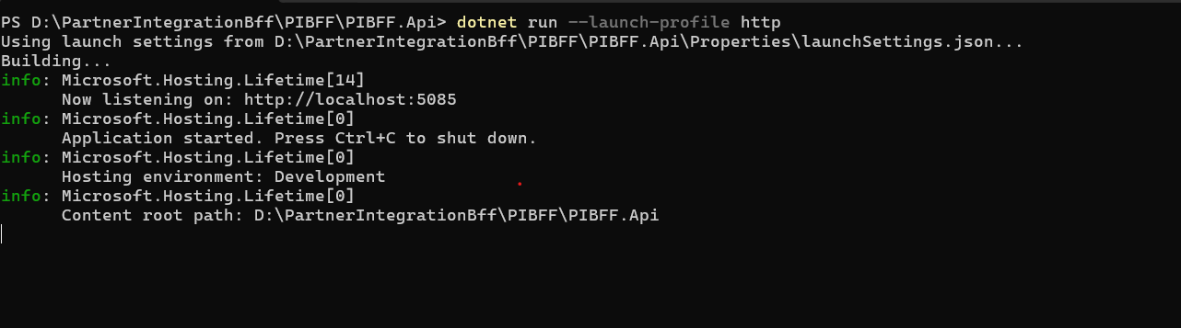

- Run test all case
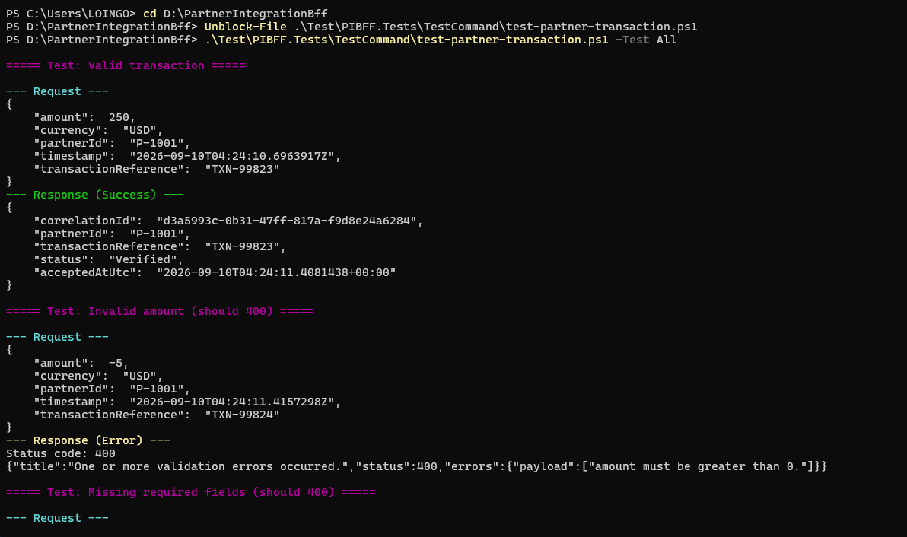

- Check parnerId
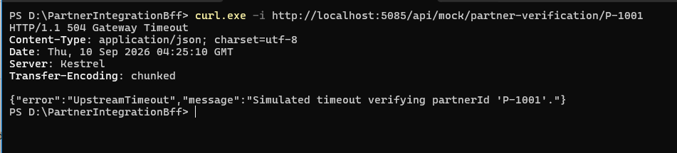

- Test all case
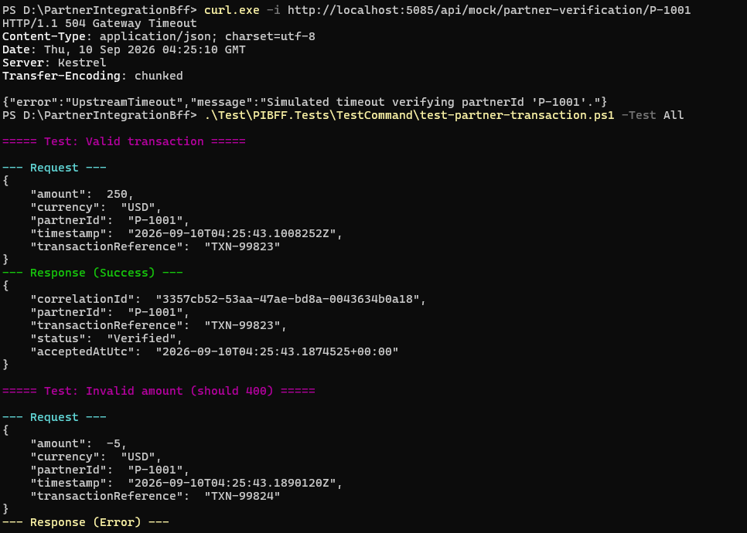

- Test class
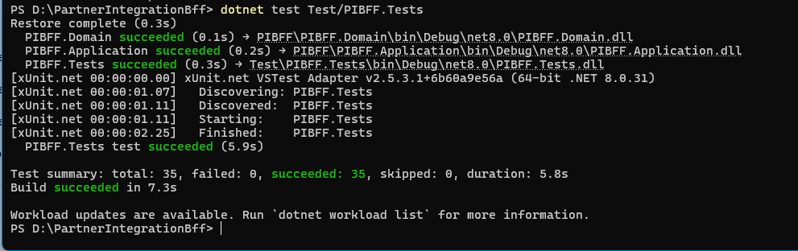

- Export report test case
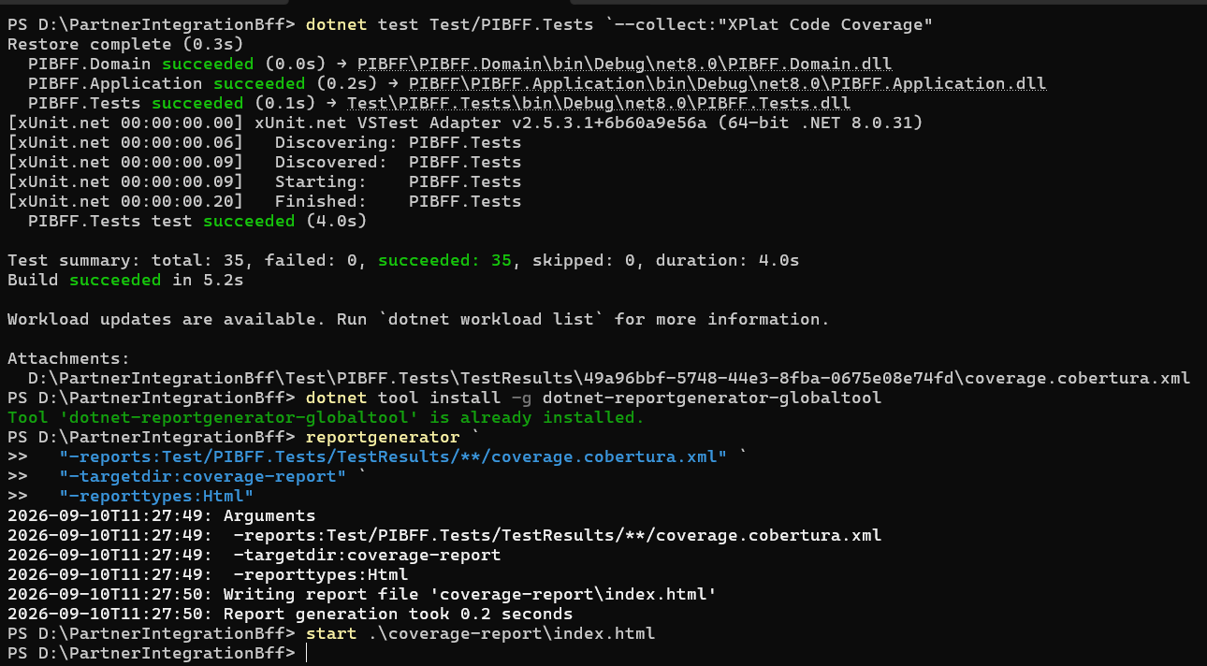
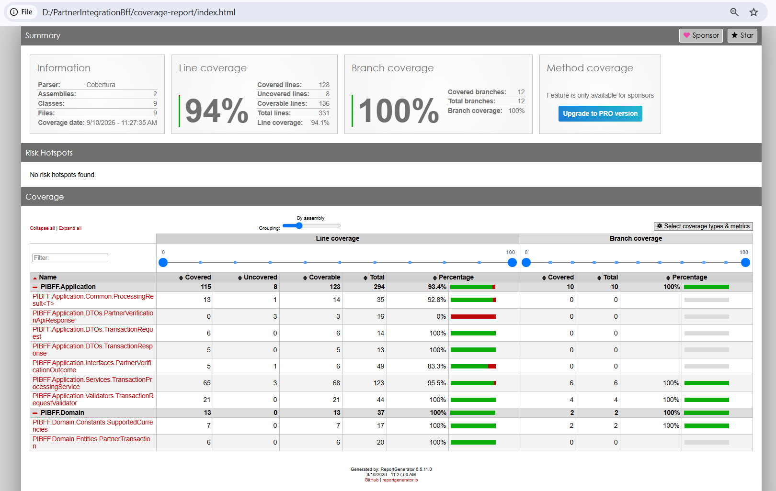

- Review queue
